***Task 1: Short Answer Questions GLA-2370300004***

1. **What is the motivation behind Retrieval-Augmented Generation (RAG)?**

The need to overcome the drawbacks of pre-trained language models (LLMs), particularly their inability to access current or domain-specific information that might not be included in their training data, is what drives retrieval-augmented generation (RAG). LLMs are trained on massive datasets, but once trained, they cannot incorporate new information unless re-trained or fine-tuned, which is both time-consuming and expensive. RAG addresses this issue by combining retrieval-based systems with generative models. At query time, it enables the system to retrieve pertinent information or documents from an outside source. This improves performance in specialized domains, increases factual accuracy, and permits real-time knowledge access.RAG systems offer a means of "grounding" the generation in actual documents, improving the reliability and interpretability of the results. It is especially helpful for tasks requiring current or referenced responses, enterprise settings, and personal assistants.

**2. Explain the difference between RAG and standard LLM-based QA.**

Standard LLM-based Question Answering (QA) systems rely solely on the internal knowledge of a pre-trained language model. These models generate answers based on the data they were trained on and cannot access external sources or update their knowledge unless they are re-trained. This means their responses may be outdated or limited, especially in specialized or fast-evolving domains. In contrast, Retrieval-Augmented Generation (RAG) enhances this process by incorporating a retrieval step before generation. When a question is asked, the RAG pipeline first retrieves relevant context from an external knowledge base or document store using semantic similarity (e.g., via embeddings and a vector store). This retrieved content is then provided as context to the language model, which uses it to generate a more accurate and grounded answer. Therefore, while standard QA is purely generative and fixed in knowledge, RAG is dynamic and can produce responses based on both existing training and real-time document retrieval. This approach improves transparency, trustworthiness, and adaptability of LLMs in real-world applications like legal research, technical support, and academic summarization.

**3.What is the role of a vector store in a RAG pipeline?**

A fundamental part of the Retrieval-Augmented Generation (RAG) pipeline, a vector store is in charge of storing and retrieving document embeddings according to semantic similarity. To increase efficiency, documents are first divided into smaller pieces before being transformed into numerical vectors by an embedding model (OpenAI, HuggingFace, etc.).These vectors represent the semantic content of each chunk and are stored in the vector store, such as FAISS, ChromaDB, Pinecone, or Weaviate. At query time, the user's input is also embedded into a vector, which is then compared against the stored vectors to retrieve the most relevant chunks. These top-matching documents are used as context for the language model to generate accurate and relevant answers.  Quick similarity searches across sizable document collections are made possible by the vector store, guaranteeing that the most contextually relevant data is found. Real-time semantic search would be impractical and computationally costly without a vector store. To put it briefly, the vector store serves as the RAG system's memory, allowing for contextual, accurate, and scalable retrieval for better language generation.

**4. Compare “stuff”, “map_reduce”, and “refine” document chain types in LangChain**

LangChain provides different document chain types—“stuff”, “map_reduce”, and “refine”—each designed to handle multiple documents during generation, depending on the use case and size of the input.

* **Stuff**: This is the simplest chain type. It concatenates all document chunks into a single large prompt and passes it to the LLM. It works well for small documents that can fit within the model’s context window but fails when the input is too large.
* **Map_reduce**: This chain processes each document (or chunk) separately using a "map" step, generating individual outputs. Then, it combines (or reduces) these outputs into a final response. It's more scalable than "stuff" and suitable for summarizing or answering from large document sets.
* **Refine**: In this type, the model starts by generating an initial answer from the first document. Then, it iteratively refines the answer using subsequent documents. Each step builds upon the previous output, which allows for deeper integration of new information, but at a higher computational cost.

Each method balances trade-offs between performance, context size, and generation quality. Choosing the right chain depends on document size and the desired level of synthesis.

**5. What are the main components of a basic LangChain RAG pipeline?**

A basic RAG pipeline using LangChain includes several key components that work together to enable retrieval-augmented generation:

1. **Document Loader**: Loads external documents from various formats (PDFs, text files, web pages) into the system.
2. **Text Splitter**: Splits documents into smaller, manageable chunks (e.g., 500 tokens), which helps in efficient retrieval and avoids exceeding the LLM's context limit.
3. **Embeddings Model**: Converts text chunks into high-dimensional vector representations using models like OpenAI Embeddings, HuggingFace Transformers, or SentenceTransformers.
4. **Vector Store**: A database (like FAISS, Chroma, or Pinecone) where the vectorized document chunks are stored and indexed for similarity search.
5. **Retriever**: Queries the vector store with the user’s embedded question and retrieves the top relevant chunks based on cosine similarity or other metrics.
6. **LLM Chain**: Combines the retrieved context with the user’s question and sends it to a language model (like GPT or LLaMA) to generate the final answer.

----🡪>>>>

***Task 2: RAG Pipeline Diagram***

Draw or describe the flow of a RAG system showing:

● User Query

● Retriever

● Vector Store

● LLM

● Final Answer Generation

+-------------+

| User Query |

+------+------+

|

v

+------+------+

| Embed Query |

+------+------+

|

v

+------+------+

| Vector Store|

| (Similarity |

| Search) |

+------+------+

|

Top-k Relevant Docs (Chunks)

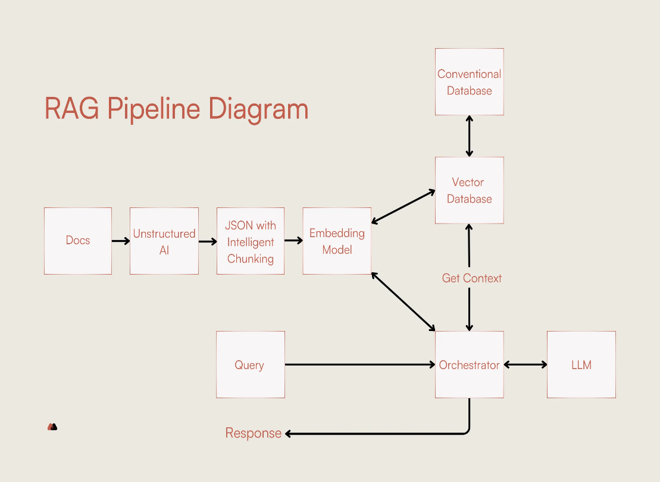 |

v

+------+------+

| Retriever |

+------+------+

|

Retrieved Context

|

v

+------+------+

| LLM |

| (Prompt + |

| Context) |

+------+------+

|

Generated Response

v

+------+------+

| Final Answer |

+-------------+

**1. User Query**

The RAG pipeline starts with a user inputting a natural language question, such as “What is deep learning?” This query expresses the user’s information need and acts as the trigger for the entire system. The query must be processed in a way that allows semantic understanding, so it can be matched with relevant information stored in the system. Unlike traditional keyword search, RAG uses semantic similarity to retrieve relevant content. This means the user's query can be flexible in wording while still retrieving the right information. It's the entry point for real-time, context-aware question answering.

**2. Embed Query**

Once the user submits a query, it is passed through an embedding model like OpenAI or HuggingFace to convert it into a high-dimensional vector. This vector numerically represents the semantic meaning of the query. Instead of matching words, the system now compares ideas or concepts using vector similarity. This transformation enables the system to find documents that are conceptually related to the query, even if they don’t use the exact same words. Embedding is essential for enabling semantic search in the vector store, making the retrieval process more accurate and flexible than keyword-based systems.

**3. Vector Store (Similarity Search)**

The embedded query is compared against a collection of document vectors stored in a vector store like FAISS or ChromaDB. These stored vectors represent pre-processed chunks of documents, also transformed using the same embedding model. The vector store performs a similarity search—usually based on cosine similarity—to find the top-k most relevant document chunks. These chunks contain information closely related to the query's meaning. The use of a vector store allows fast and efficient retrieval from large document sets, making the RAG system scalable and responsive for real-time applications.

**4. Retriever**

The retriever component fetches the top-matching document chunks from the vector store and prepares them for the LLM. These chunks provide external context, which is crucial for the language model to generate grounded, informative answers. The retriever ensures only the most relevant content is passed to the LLM, helping control prompt length and focus the model’s attention. It acts as a bridge between the search (vector store) and the generation (LLM) stages. A good retriever improves answer accuracy by filtering out unrelated or low-quality content and delivering only the most semantically relevant information.

**5. LLM (Language Model)**

The Language Model (LLM), such as GPT-4 or LLaMA, receives the original user query along with the retrieved document chunks as additional context. It uses this combined prompt to generate a detailed and context-aware answer. The LLM doesn't rely solely on its internal memory but incorporates external documents to support its response. This process improves factual accuracy, transparency, and the ability to cite sources. The LLM’s role is to interpret the context, understand the user’s intent, and compose a coherent response. This is the generative part of the RAG pipeline.

**6. Final Answer Generation**

After the LLM processes the input and retrieved documents, it generates a human-readable, context-informed answer. This final output is returned to the user as a response to their original query. Because the response is grounded in relevant documents retrieved in real time, it is more accurate, up-to-date, and reliable. The final answer may also include references or explanations that help the user understand the source of information. This stage completes the RAG cycle, combining retrieval and generation into a single, intelligent response system designed for modern applications like chatbots, knowledge bases, and search assistants.

****